Stability and Change Within an Ecosystem
The graph below represents the Annual Precipitation for the State of Utah from 2012-2021.
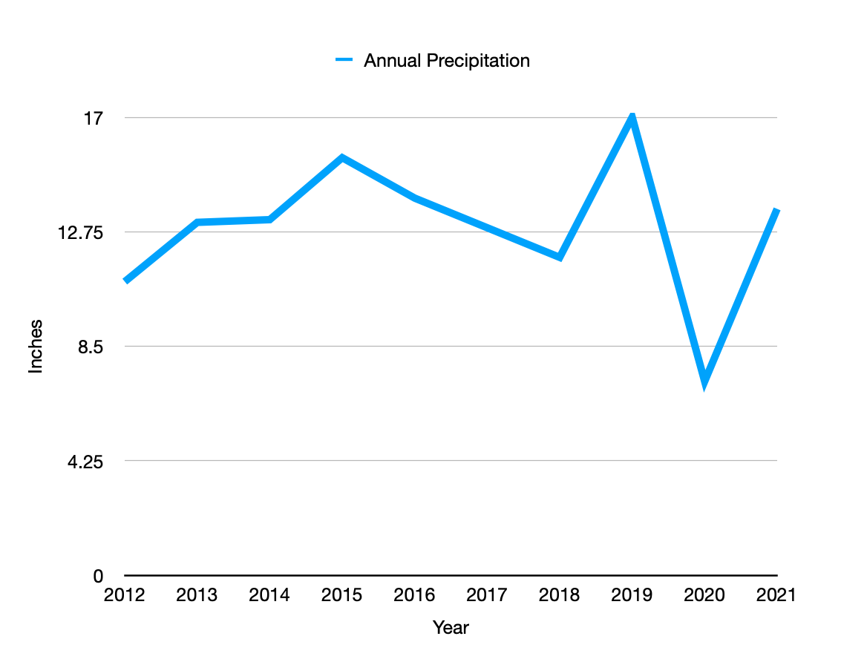
- Based on the graph above, draw lines new graph lines to represent what you think the trend of the following populations will be:
  - Deer population
  - Quantity of vegetation
- For each of the new graph lines you drew, provide an explanation as to why you drew the line you did.
  - Deer population -

  - Quantity of vegetation -

- Using the evidence you have, develop an argument to explain the potential impacts of drought on the stability of an ecosystem. (This should be about ½ page or 2-3 solid paragraphs).

- When biological or physical changes occur within an ecosystem, they are described as having either a moderate impact or an extreme impact on the ecosystem. A moderate impact is generally more temporary, and the effects are reversible. An extreme impact is not reversible and causes a permanent change to an ecosystem. Using the data you have explored, would the drought impacting Utah and the surrounding area for the given years represent a moderate or an extreme impact on the ecosystem? Be sure to include specific evidence from the data to support your reasoning. (This should be about ½ page or 2-3 solid paragraphs)

