Video Notes
General Observations | Organisms

Food Web
Develop a simple model to represent the flow of energy in a food web of this ecosystem using evidence from the video, your prior knowledge, and living things you infer are present.

Remember arrows in a food web point in the direction of matter and energy flow. Here is an example of an aquatic ecosystem food web.
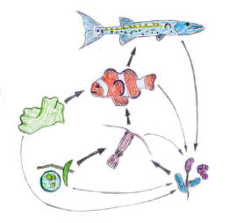
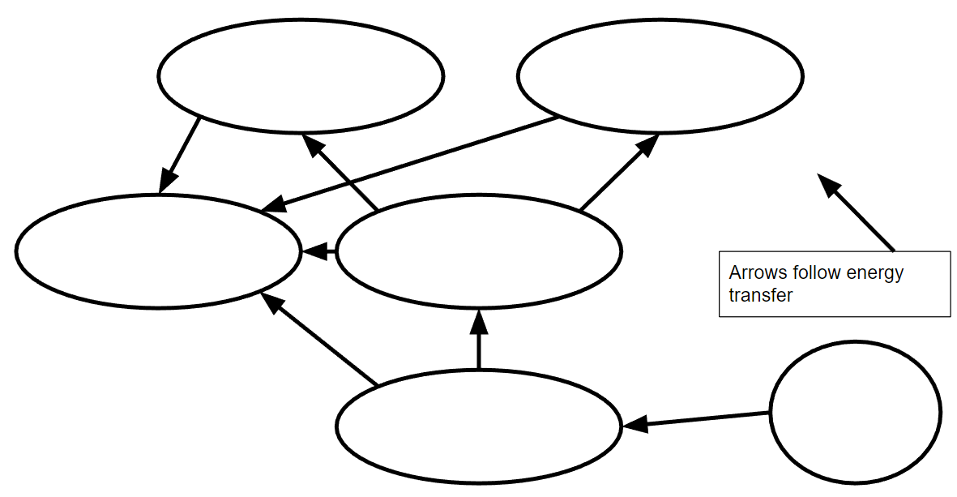

Word Bank: Bear, Grass, Elk, Crow, Sun, Decomposers

Questions
- In your model of the ecosystem’s food web, what is the source of energy? If you do not have a source of energy, modify your model to include one or more sources, then answer this question.

- Describe where each organism in your web gets its energy. Where do producers get their energy?

- In the search for food, what will happen to an organism if it uses more energy than it consumes?

- What strategies does the bear use to reduce competition from other species for the energy source?

- What strategies do other species use to compete with the bear for the energy source?
Competition for Energy Memory Game

- Pick your animal card
- Each person takes a turn flipping over 2 cards and seeing if the cards are identical.
- If they match, and your animal can eat them, then add the kcal (energy) amount on each card to get your energy earned for that turn.
- If they don’t match or your animal can’t eat them, flip the cards over and return them to the board.
- Fill out the data tables below. After ten rounds, add the total kcal to see if your animal survived the round.

Round 1 |  | Round 2
Turn Number | kcal earned | Turn Number | kcal earned
- 1 |  | - 1
- 2 |  | - 2
- 3 |  | - 3
- 4 |  | - 4
- 5 |  | - 5
- 6 |  | - 6
- 7 |  | - 7
- 8 |  | - 8
- 9 |  | - 9
- 10 |  | - 10
Food Energy Total: |  | Food Energy Total:

Round 1 Data Table:
Partner | Your chosen animal | Number of calories to survive | Number of calories consumed | Did your animal survive? | What was your animal’s highest food source?
1
2

Round 2 Data Table:
Partner | Your chosen animal | Number of calories to survive | Number of calories consumed | Did your animal survive? | What was your animal’s highest food source?
1
2
Summary Questions
- Which animal did you select for round one? What were the advantages and disadvantages of that choice in terms of energy and competition?

- Which animal did you select for round two, and why did you choose it? Justify your response using your understanding of energy and competition.

- Write an explanation of competition for energy resources using evidence from the two models (the food web you built and the game you played).

- What are the strengths and weaknesses of the two models (the food web you built and the game you played) to illustrate the competition of species for limited energy resources?

