Gummy Bear Pedigree
Procedure
Part 1: F1 Generation
Offspring receive roughly ½ their genetic information from parent A and ½ from parent B.

You should have two bags with different gummy bears colors (6 bears each). On your pedigree on the next page, you will see the “P” (Parent) generation.
- Place one gummy bear of each color into the “P” generation.
- Assume gummy bear offspring get ½ of their traits from each parent. Using your razor blade, cut two gummy bears identical to those found in the P generation. Rearrange pieces of the parent gummy bears into hybrid gummy bears that model how the offspring in the first filial (F1) generation will appear (phenotype).

Analysis:
You chose a particular way to cut your gummy bears to model the passing of genetic information from parents to offspring. Make a claim about how the inheritance from parents to offspring causes genetic variation. Support your claim using evidence from your gummy bear models.

Part 2: F2 Generation
- Next, make a copy of one of your F1 generation gummy bears.
- Take a copy of your F1 generation and both parent colors and trade with another group, taking both parent colors and their F1 model.
- Now create a model for the offspring generation. Use your razor blade and F1 generation models to rearrange the pieces into hybrid gummy bears that model how the second filial generation (F2) will appear (phenotype). Ensure that your models of F2 are inheriting about half of the genetic information from each of their parents.

Analysis:
You chose a particular way to cut your gummy bears to model the passing on of genetic information from parents to offspring. Make a claim about how inheritance from parents to offspring across multiple generations causes genetic variation. Support your claim using evidence from your F2 gummy bear models.

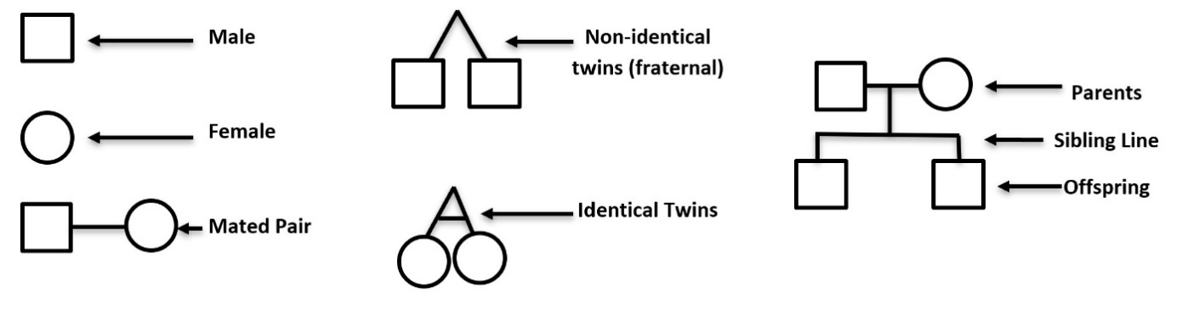
Pedigree Key:

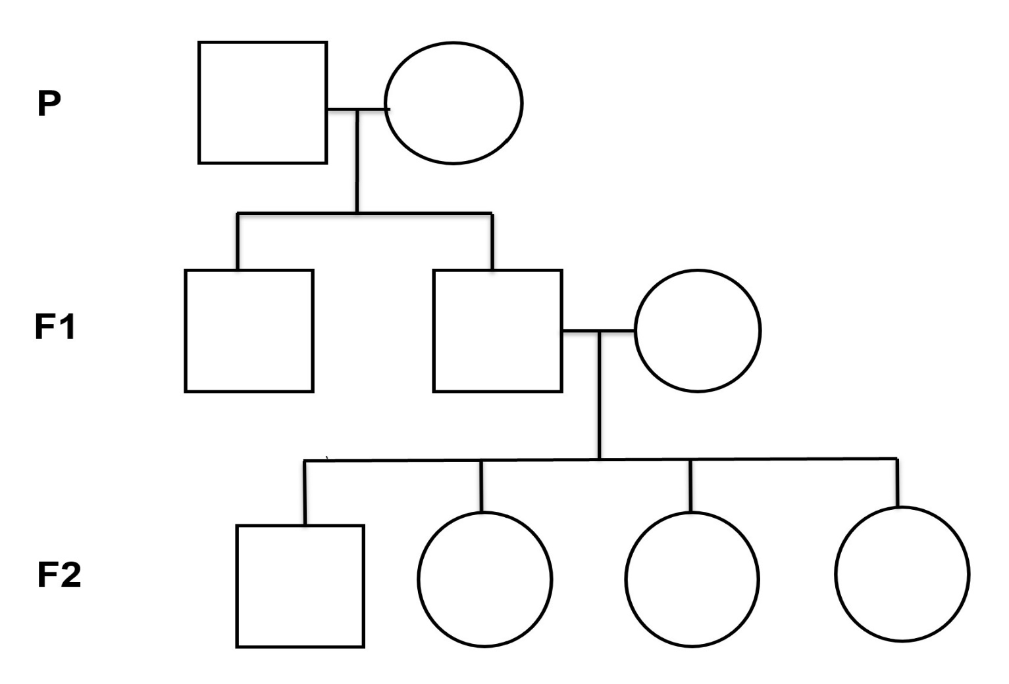
Part 3: F3 Generation
Analysis:
- Predict what your (F3) generation offspring would look like if one of your F2 generation reproduced with the bear below. Color your predictions on the pedigree chart to show the phenotype of the F3 gummy bears.
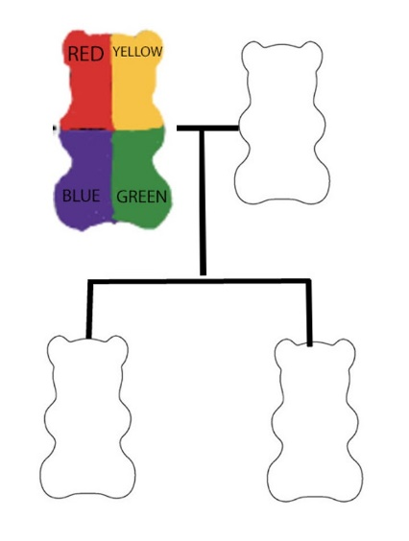
- Look at the F2 and F3 generation gummy bears from several other groups. Based on what you’ve learned from this activity, what causes the variation in phenotype (appearance) of offspring?

- Given the amount of variation in F2 and F3 gummy bears that you observed, do you think it is possible that all three images show sets of twins? Make a claim about whether or not they are twins. Support your claim with evidence and reasoning from the gummy bear models.

